PRESS RELEASE:
WOMEN ON TOP
A GROUP EXHIBITION
Featuring: Linnea Glatt, Terrell James, Jessica Sinks, Lorraine Tady, Terri Thornton, and Liz Trosper.
January 18 – February 22, 2020

To commence a new year, Barry Whistler Gallery will present a group exhibition of Texas’
paragon abstract artists—at the top of their game. Six artists are included in “Women on Top”: Linnea Glatt, Terrell James, Jessica Sinks, Lorraine Tady, Terri Thornton, and Liz Trosper.

Four of these artists (Glatt, James, Tady, and Trosper) are also included in the seminal
exhibition, “Texas Women: A New History of Abstract Art”--which features a total of 17 artists--curated by Suzanne Weaver opening at the San Antonio Museum of Art, February 7th, 2020.

Women on Top opens at BWG on Saturday, January 18th, 2020, with an opening reception that evening from 6-8PM. The title is derived from Smith’s College’s centennial celebration “A Century of Women on Top”. Terri Thornton stated, “While the title of the exhibition is as provocative as it is true, the work of the women represented here makes a strong case that good art knows itself and in doing so, deserves a place at the top”.

LINNEA GLATT
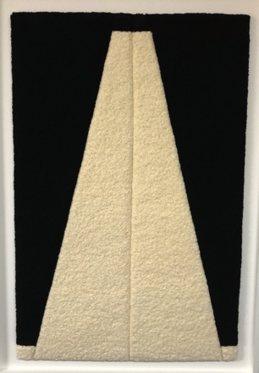
Double Inversion 1, 2019
Cotton fabric
44 x 29 x 1 inch(es)

Living and working in Dallas, Texas, Linnea Glatt’s work has always investigated progressions and patterns. Her intricate and soft works on fabric mean to discover transformations and their tie to the human experience. “The work has often been presented as a progression of images from one state to another. I intuitively gravitate toward geometry and symmetry, stripped down and essential. Material usage is exploited as a vehicle.”

TERRELL JAMES
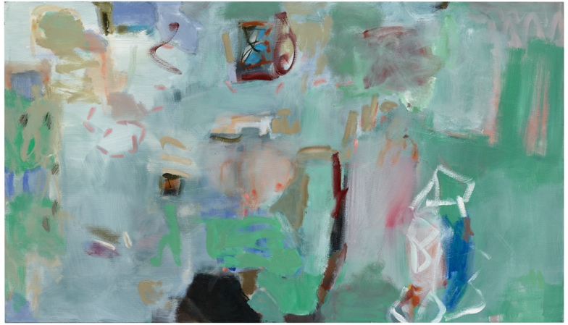
Portal, 2017
Oil on canvas
30 x 52 inches

Based in Houston, Terrell James’ career has been comprised of gentle canvas and stretching murals employing oil. Her Field Studies are a perfect example of her fascination with internal and external landscapes. “The ‘Field Studies’ represent a sort of pun in painting. As I key into the tradition of color note taking outdoors (in the field), the pieces convey specific colors as they appear in nature.” The show will include two of James’ larger works on canvas.

JESSICA SINKS
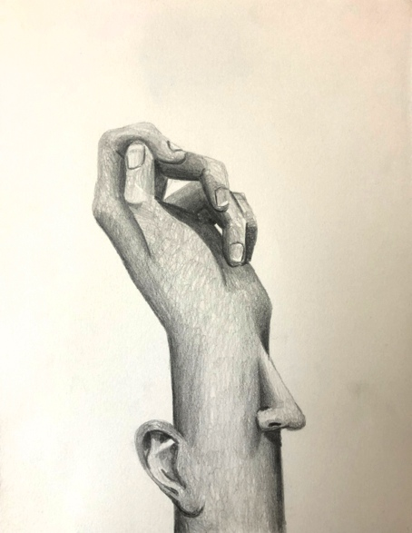
Vestigial Portrait, 2019
Graphite on paper
7 ½ x 9 ½ inches

Returning to Texas after completing her MFA from NYU in 2019, Jessica Sinks work to be included begs questions of certainty. The form of an object, in your head, your account of it, vastly differs from its’ reality. “It is a pleasure to doubt certainty. When my mind is still soft from sleep I practice re-looking trusted visuals such as hands and home and flowers and vases. They blend and blur into familiarly new shapes, then from thin paper I cut free their shadows.” Sinks’ work in the show will include graphite drawings and cut outs, as well as, a series of video works. These pieces begin to muddy the reality of their shapes and figures.

LORRAINE TADY
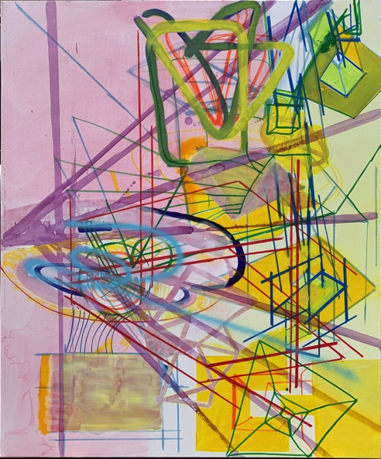
Overlook Mountain, Woodstock NY (House Inter-related Potential, Octagon Vibration Series 2 – Tryp 3), 2020
Acrylic on canvas
72 x 60 inches

Tady’s three canvases included in Women On Top is a response to her recent trip to Overlook Mountain in Woodstock New York that also has a Tibetan Buddhist Monastery, the ruins of an old hotel, and a lookout tower. “The Overlook Mountain, Woodstock, NY, triptych reflects the ongoing, back and forth dialog between analog and digital processes in my painting practice”. Her alluring compositions address both the languages drawing and painting. She displays her unique interest in perspective and the geometry of architectural masses and spaces while also alluding to the organic quality of our experience.

TERRI THORNTON
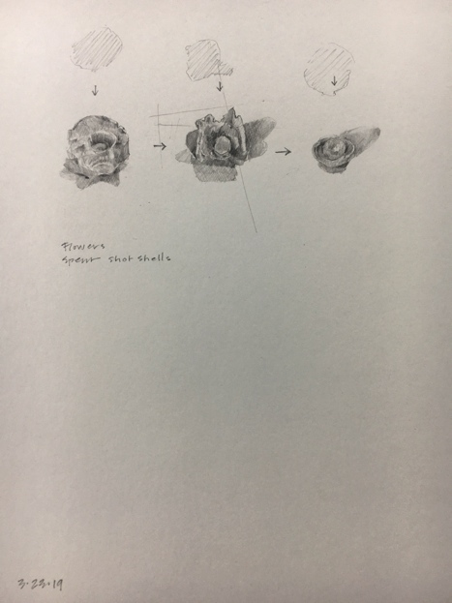
Spent Shot Studies, 2019
Pencil on paper
15 ½ x 18 inches

Fort Worth artist, and Curator of Education at The Modern in Fort Worth, Terri Thornton studies forms by first drawing them. In discussion for the upcoming exhibition she recounts stories of her fascination with spent ammunition. Collecting the pieces and analyzing their meaning by means of drawing these bent and knarred objects

lend to her practice of exploration. Of the pieces included in the show Thornton said, “…I was drawn to these beautiful bits of residue from such a negative force” and “I began to develop a language that I was learning as it formed. Another reminder of what drawing offers me as I am looking for ways to know and share…”.

LIZ TROSPER
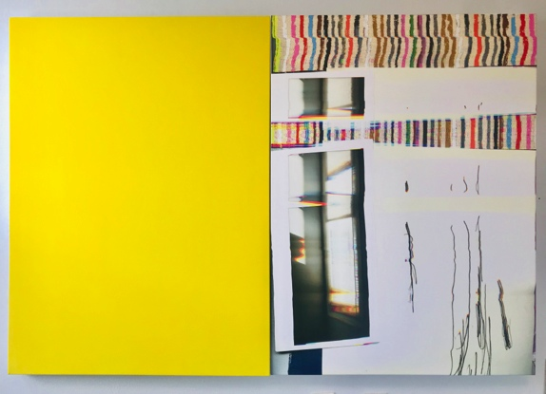
let me open a window: yellow, 2019
UV ink on canvas with acrylic and serigraph ink on canvas
40 x 60 inches

Now teaching at University of North Texas, Liz Trosper has always questioned what constitutes a contemporary painting. She continues to question the nature of a painting in her two pieces featured in the upcoming exhibition. The work, layered in physical objects, and partially printed in UV inks on canvas, does just that. “What is this new way of making paintings? That’s what I ask in these works. I want to see what it means to be literal while also theoretical and poetic.”

Additional information and images available upon request

